

A Project Report on

INTERNET SERVICE PROVIDER AUTOMATION SYSTEM

Submitted in partial fulfillment of requirements for the award of the course of

EGB1201-JAVA PROGRAMMING
Under the guidance of

Ms.N.Valarmathi, M.Tech., Assistant Professor / IT
Submitted By

SUDHAGAR A (927624BEC223)

DEPARTMENT OF ELECTRONICS AND COMMUNICATION ENGINEERING

M.KUMARASAMY COLLEGE OF ENGINEERING
(Autonomous)

KARUR – 639 113
DECEMBER 2025

M. KUMARASAMY COLLEGE OF ENGINEERING
(Autonomous Institution affiliated to Anna University, Chennai) KARUR – 639 113

BONAFIDE CERTIFICATE

This is to certify that this project report on “INTERNET SERVICE PROVIDER AUTOMATION SYSTEM” is the bonafide work of SUDHAGAR A (927624BEC223) who carried out the project work during the academic year 2025 - 2026 under my supervision.

Signature Signature
Ms.N.VALARMATHI, M.Tech., Dr.N. MAHENDRAN, Ph.D.,
SUPERVISOR, HEAD OF THE DEPARTMENT,
Department of Information Technology, Department of Electronics and
Communication Engineering, M.Kumarasamy College of Engineering, M.Kumarasamy College of
Engineering,
Thalavapalayam, Karur -639 113. Thalavapalayam, Karur -639 113.

DEPARTMENT OF ELECTRONICS AND COMMUNICATION ENGINEERING
VISION OF THE INSTITUTION

To emerge as a leader among the top institutions in the field of technical education

MISSION OF THE INSTITUTION

- Produce smart technocrats with empirical knowledge who can surmount the global challenges
- Create a diverse, fully-engaged, learner-centric campus environment to provide quality
education to the students
- Maintain mutually beneficial partnerships with our alumni, industry, and Professional associations

DEPARTMENT VISION, MISSION, PEO, PO AND PSO

VISION
To empower the Electronics and Communication Engineering students with emerging technologies, professionalism, innovative research and social responsibility.

MISSION

M1: Attain the academic excellence through innovative teaching learning process, research areas & laboratories and Consultancy projects.
M2: Inculcate the students in problem solving and lifelong learning ability.

M3: Provide entrepreneurial skills and leadership qualities.

M4: Render the technical knowledge and skills of faculty members.

PROGRAM EDUCATIONAL OBJECTIVES (PEOs)
- PEO1: Core Competence: Graduates will have a successful career in academia or industry associated with Electronics and Communication Engineering
- PEO2: Professionalism: Graduates will provide feasible solutions for the challenging problems through comprehensive research and innovation in the allied areas of Electronics and Communication Engineering.
- PEO3: Lifelong Learning: Graduates will contribute to the social needs through lifelong learning, practicing professional ethics and leadership quality.

PROGRAM OUTCOMES (POs)
Engineering students will be able to:
- Engineering knowledge: Apply the knowledge of mathematics, science, engineering fundamentals, and an engineering specialization to the solution of complex engineering problems.
- Problem analysis: Identify, formulate, review research literature, and analyze complex engineering problems reaching substantiated conclusions using first principles of mathematics, natural sciences, and engineering sciences.
- Design/development of solutions: Design solutions for complex engineering problems and design system components or processes that meet the specified needs with appropriate consideration for the public health and safety, and the cultural, societal, and environmental considerations.
- Conduct investigations of complex problems: Use research-based knowledge and research methods including design of experiments, analysis and interpretation of data, and synthesis of the information to provide valid conclusions.
- Modern tool usage: Create, select, and apply appropriate techniques, resources, and modern engineering and IT tools including prediction and modeling to complex engineering activities with an understanding of the limitations.
- The engineer and society: Apply reasoning informed by the contextual knowledge to assess societal, health, safety, legal and cultural issues and the consequent responsibilities

relevant to the professional engineering practice.
- Environment and sustainability: Understand the impact of the professional engineering solutions in societal and environmental contexts, and demonstrate the knowledge of, and need for sustainable development.
- Ethics: Apply ethical principles and commit to professional ethics and responsibilities and norms of the engineering practice.
- Individual and team work: Function effectively as an individual, and as a member or leader in diverse teams, and in multidisciplinary settings.
- Communication: Communicate effectively on complex engineering activities with the engineering community and with society at large, such as, being able to comprehend and write effective reports and design documentation, make effective presentations, and give and receive clear instructions.
- Project management and finance: Demonstrate knowledge and understanding of the engineering and management principles and apply these to one’s own work, as a member and leader in a team, to manage projects and in multidisciplinary environments.
- Life-long learning: Recognize the need for, and have the preparation and ability to engage in independent and life-long learning in the broadest context of technological change.

PROGRAM SPECIFIC OUTCOMES (PSOs)
- PSO1: Applying knowledge in various areas, like Electronics, Communications, Signal processing, VLSI, Embedded systems etc., in the design and implementation of Engineering application.
- PSO2: Able to solve complex problems in Electronics and Communication Engineering with
analytical and managerial skills either independently or in team using latest hardware and software tools to fulfil the industrial expectations.

ACKNOWLEDGEMENT
We gratefully remember our beloved Founder Chairman, (Late) Thiru. M. Kumarasamy, whose vision and legacy laid the foundation for our education and inspired us to successfully complete this project.
We extend our sincere thanks to Dr. K. Ramakrishnan, Chairman, and Mr. K. R. Charun Kumar, Joint Secretary, for providing excellent infrastructure and continuous support throughout our academic journey.
We are privileged to extend our heartfelt thanks to our respected Principal, B. S. Murugan, B.Tech., M.Tech., Ph.D., for providing us with a conducive environment and constant encouragement to pursue this project work.
We sincerely thank Dr.N.Mahendran M.E.,Ph.D., Professor and Head, Department of Electronics and Communication Engineering, for his continuous support, valuable guidance, and motivation throughout the course of this project.
Our special thanks and deep sense of appreciation go to our Project Supervisor, Ms.N.Valarmathi,M.Tech., Assistant Professor, Department of Information Technology, for her exceptional guidance, continuous supervision, constructive suggestions, and unwavering support, all of which have been instrumental in the successful execution of this project.
We would also like to acknowledge Dr.M.Dharani Devi, M.E.,Ph.D., Associate Professor, our Class Advisor for his constant encouragement and coordination that contributed to the smooth progress and completion of our project work.
We gratefully thank all the faculty members of the Department of Electronics and Communication Engineering for their timely assistance, valuable insights, and constant support during various phases of the project.
Finally, we extend our profound gratitude to our parents and friends for their encouragement, moral support, and motivation, without which the successful completion of this project would not have been possible.

ABSTRACT

The ISP Automation System is a web-based management platform designed to streamline Internet Service Provider operations. It integrates modules for customer management, billing, network monitoring, and troubleshooting within a unified dashboard. The system provides real-time insights such as active customers, revenue, ticket status, and network performance using dynamic charts. It enables automated invoice generation, ticket management, and customer record handling to reduce manual workload. The interface is fully interactive, responsive, and user-friendly, allowing administrators to manage ISP activities efficiently.

ABSTRACT WITH POs AND PSOs MAPPING

ABSTRACT | COs  MAPPE D | POs  MAPPE D | PSOs  MAPPE D
The ISP Automation System is a web-based | CO1 | PO1 | PSO1
management platform designed to streamline | CO2 | PO2 | PSO2
Internet Service Provider operations. It | CO3 | PO3
integrates modules for customer management, | CO4 | PO4
billing, network monitoring, and troubleshooting |  | PO5
within a unified dashboard. The system provides |  | PO6
real-time insights such as active customers, |  | PO7
revenue, ticket status, and network performance |  | PO8
using dynamic charts. It enables automated |  | PO9
invoice generation, ticket management, and customer record handling to reduce manual workload. The interface is fully interactive, |  | PO10 PO11 PO12
responsive, and user-friendly, allowing
administrators to manage ISP activities
efficiently.

TABLE OF CONTENTS

CHAPTER  No. | TITLE | PAGE  No.
 | ABSTRACT
1 | INTRODUCTION
 | 1.1 OBJECTIVE | 1
 | 1.2 OOPS CONCEPTS | 1
 | 1.3 LITERATURE SURVEY | 2
2 | PROJECT METHODOLOGY
 | 2.1 PROPOSED WORK | 3
 | 2.2 ARCHITECTURE | 3,4
3 | MODULE DESCRIPTION
 | 3.1 CUSTOMER MANAGEMENT MODULE | 5
 | 3.2 USAGE TRACKING MODULE | 5
 | 3.3 BILLING & PAYMENT MODULE | 5
 | 3.4 TROUBLESHOOTING & SUPPORTING  MODULE | 6
 | 3.5 NOTIFICATION AND ALERTS MODULE | 6
4 | RESULTS AND DISCUSSION | 7 and 8
5 | CONCLUSION | 9
 | REFERENCES | 9
 | APPENDIX | 10

- OBJECTIVE

CHAPTER 1 INTRODUCTION

The main objective of the ISP Automation System is to provide a centralized platform for managing customers, billing, network usage, and technical support efficiently. It aims to automate routine ISP operations such as invoice generation, ticket handling, and performance monitoring. The system ensures faster decision- making through real-time data visualization and improves service quality by reducing manual errors.

OOPS CONCEPTS

The ISP Automation System follows OOPS concepts by treating each module— Customers, Billing, Network Usage, and Tickets—as separate classes with their own data and functions. Every customer, invoice, and ticket acts as an object created from these classes.
Encapsulation is seen when data is updated only through specific forms and functions, ensuring security and controlled access. Inheritance can be applied by extending base classes like Customer for Premium or Business users.
Polymorphism appears when methods such as displaying details or calculating bills work differently across various modules.

LITERATURE SURVEY

- Internet Service Provider Management System — Project/Paper (May 2022) This project developed a web-based ISP management system focusing on customer registration, billing, and support ticket handling. It demonstrated improvements in reducing manual paperwork and streamlining customer service. However, it lacked real-time network monitoring and advanced analytics, limiting operational efficiency. The system provided a solid foundation for automation but required enhancements in dashboards and automated workflows for better ISP management.

Telco / Network Automation Surveys & Industry Reports (2023)
Recent industry reports highlight the growing adoption of automation in telecom networks, focusing on real-time monitoring, fault detection, and workflow automation. Operators increasingly rely on integrated dashboards and telemetry data to improve service reliability. However, full end-to-end automation remains a challenge due to complexities in integration and legacy systems. These insights emphasize the need for scalable ISP systems combining customer management with network analytics and automated billing.

CHAPTER 2 PROJECT METHODOLOGY

PROPOSED WORK
The proposed work focuses on developing a web-based Internet Service Provider Automation System that streamlines customer management, plan subscription, billing operations, and service request handling. The system integrates an interactive user interface to manage customer data, track usage, generate invoices, and monitor complaints in real time. By automating core ISP processes, the platform aims to reduce manual effort, improve accuracy, and deliver faster customer service. The solution also provides scalability for integrating external services such as online payments and automated notifications in the future.

ARCHITECTURE

Presentation Layer :

This layer contains the user interface built using HTML, CSS, and JavaScript. It displays dashboards, customer pages, billing screens, and ticket forms that users interact with. Its main role is to collect user input and show processed data in a simple way.

Application Layer :

This layer handles all business logic of the ISP system. It processes customer management, billing calculations, network usage tracking, and ticket handling. It acts as the bridge between the user interface and the database.

Database Layer :

This layer stores all system data, including customer details, bills, plans, tickets, and usage records. It ensures secure data storage, fast retrieval, and smooth communication with the application layer.

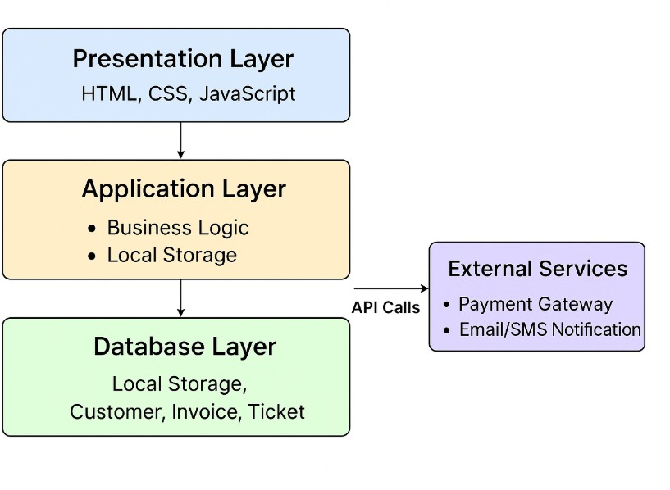

Fig.2.1.Architecture diagram

CHAPTER 3 MODULE DESCRIPTION

Customer Management Module:
The Customer Management Module is responsible for handling all user-related activities such as registration, login, and profile maintenance. It securely stores customer information and allows them to update details like address, phone number, and plan preferences. The module enables users to subscribe, change, or upgrade their internet plans with ease. It also provides separate access levels for customers and administrators to maintain system security. Through streamlined management processes, it ensures smooth on-boarding and efficient user handling.

Usage Tracking Module:
This module continuously monitors the internet usage of each customer in real-time, including download speed, upload speed, and total data consumed. It records usage patterns and stores them in logs to support accurate billing and analytic. The system also generates automatic alerts when users approach their data limits. With these insights, administrators can evaluate network load and plan capacity upgrades. Overall, it ensures transparency and efficient usage monitoring.

Billing & Payment Module:
The Billing and Payment Module automates the creation of invoices based on customer usage and subscribed plans. It includes automated tax calculations, discount applications, and due-date scheduling to minimize manual errors. The system supports secure payment processing through integrated gateways for online transactions. It maintains complete financial records, including paid, pending, and overdue invoices. This module ensures smooth revenue management and enhances user convenience.

Troubleshooting & Support Module:
This module allows customers to raise complaints or troubleshoot issues by submitting support tickets online. Each ticket is tracked through stages such as open, in-progress, resolved, or closed. Administrators can view, assign, and resolve issues quickly using structured ticket management tools. The module improves service quality by maintaining detailed records of customer issues and response times. It ultimately strengthens customer trust and satisfaction.

Notification & Alerts Module:
The Notification and Alerts Module ensures timely communication by sending SMS or email alerts regarding bills, payments, service outages, and usage warnings. It helps customers stay informed about their account status and prevents missed payments or over-usage. Administrators also receive system-related alerts for better monitoring and decision-making. The module improves user engagement by delivering automated, real-time updates. Overall, it enhances system reliability and customer awareness.

RESULTS:
CHAPTER 4
RESULTS AND DISCUSSION

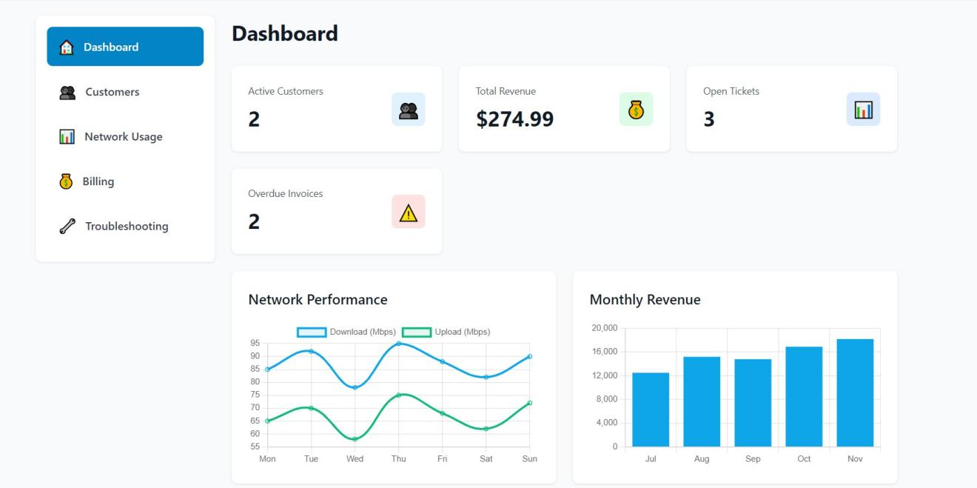
Fig.4.1

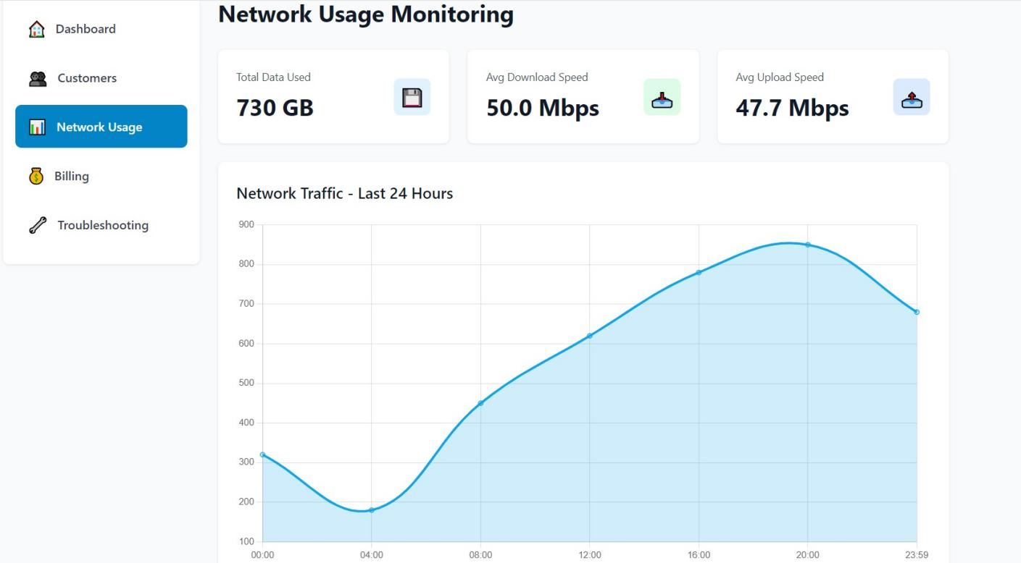
Fig.4.2

DISCUSSION:

The dashboard serves as a comprehensive control center, giving administrators quick access to every major function of the ISP automation system. The Customers section ensures easy management of user accounts, subscription plans, and profile details. Network Usage provides a detailed and real-time view of data consumption, helping maintain network stability and identify anomalies. Billing brings all financial activities together, from automated invoice generation to secure payment tracking. The Troubleshooting area supports efficient handling of technical issues by allowing staff to review tickets and run basic diagnostics. Each section is organized clearly, reducing complexity and saving operational time. Overall, the dashboard creates a streamlined environment that enhances both system performance and user experience.

CHAPTER 5
CONCLUSION

The ISP automation system dashboard provides a comprehensive overview of key business and network metrics in a user-friendly interface. By integrating customer data, revenue figures, support tickets, and network performance, it enables efficient monitoring and management. The clear visualization aids in quick decision-making, helping to maintain service quality and optimize revenue. Overall, the dashboard is a vital tool for ensuring smooth operations and enhancing customer satisfaction in the ISP environment.

REFERENCES:

1.L. Marques and A. Gaspary, “Programmable Data Planes for Large-Scale Network Analytic: A Study on In-Band Network Telemetry,” 2023 IEEE/IFIP Network Operations and Management Symposium (NOMS), Miami, USA, 2023.
2.Y. Xin, “AI-Driven Automation for Next-Generation Telecom Networks: Opportunities and Challenges,” IEEE Wireless Communications, vol. 30, no. 4, pp. 12–18, Aug. 2023.
- J. Zhou, T. Wang, and S. Li, “Privacy-Preserving Multidimensional Telemetry Using Autoencoder-Based Compression,” 2023 IEEE International Conference on Cloud Engineering (IC2E), Princeton, USA, 2023.


APPENDIX:
<div class="app-container">
<!-- Sidebar -->
<aside class="sidebar">
<nav class="nav">
<a href="#" onclick="showPage('dashboard')" class="nav-item active" data-
page="dashboard">
<span> </span> Dashboard
</a>

<!DOCTYPE html>
<html lang="en">
<head>
<meta charset="UTF-8">
<meta name="viewport" content="width=device-width, initial-scale=1.0">
<title>ISP Automation System</title>
<link rel="stylesheet" href="styles.css">
<!-- Chart.js for charts -->
<script src="https://cdn.jsdelivr.net/npm/chart.js@4.4.0/dist/chart.umd.min.js"></script>
</head>
<body>
<!-- Login Page -->
<div id="loginPage" class="login-page">
<div class="login-container">
<div class="login-icon"> </div>
<h1>ISP Automation</h1>
<p class="login-subtitle">Sign in to manage your network</p>
<form id="loginForm" onsubmit="return handleLogin(event)">
<div class="form-group">
<label for="username">Username</label>
<input type="text" id="username" class="input-field" placeholder="Enter
username" required>
</div>
<div class="form-group">
<label for="password">Password</label>
<input type="password" id="password" class="input-field" placeholder="Enter
password" required>
</div>
<button type="submit" class="btn-primary full-width">Sign In</button>
</form>
<p class="login-demo">Demo: Use any username/password to login</p>
</div>
</div>

<!-- Main Application -->
<div id="mainApp" class="main-app" style="display: none;">
<!-- Header -->
<header class="header">
<div class="header-container">
<div class="logo">
<span class="logo-icon"> </span>
<h1>ISP Automation</h1>
</div>
<button onclick="handleLogout()" class="logout-btn">
<span> </span> Logout
</button>
</div>
</header>





<a href="#" onclick="showPage('customers')" class="nav-item" data-
page="customers">
<span> </span> Customers
</a>
<a href="#" onclick="showPage('network')" class="nav-item" data-page="network">
<span> </span> Network Usage
</a>
<a href="#" onclick="showPage('billing')" class="nav-item" data-page="billing">
<span> </span> Billing
</a>
<a href="#" onclick="showPage('troubleshooting')" class="nav-item" data- page="troubleshooting">
<span> </span> Troubleshooting
</a>
</nav>
</aside>
<!-- Main Content -->
<main class="main-content">
<!-- Dashboard Page -->
<div id="dashboardPage" class="page active">
<h2 class="page-title">Dashboard</h2>

<!-- Stats Grid -->
<div class="stats-grid">
<div class="stat-card">
<div class="stat-content">
<div>
<p class="stat-label">Active Customers</p>
<p class="stat-value" id="activeCustomersCount">0</p>
</div>
<div class="stat-icon" style="background: #e0f2fe; color: #0284c7;">
</div>
</div>
</div>
<div class="stat-card">
<div class="stat-content">
<div>
<p class="stat-label">Total Revenue</p>
<p class="stat-value" id="totalRevenue">$0.00</p>
</div>
<div class="stat-icon" style="background: #dcfce7; color: #16a34a;">
</div>
</div>
</div>
<div class="stat-card">
<div class="stat-content">
<div>
<p class="stat-label">Open Tickets</p>
<p class="stat-value" id="openTicketsCount">0</p>
</div>
<div class="stat-icon" style="background: #dbeafe; color: #2563eb;">
</div>
</div>
</div>
<div class="stat-card">
<div class="stat-content">
<div>
<p class="stat-label">Overdue Invoices</p>
<p class="stat-value" id="overdueInvoicesCount">0</p>
</div>


<div class="stat-icon" style="background: #fee2e2; color:
#dc2626;"> </div>
</div>
</div>
</div>
<!-- Customers Page -->
<div id="customersPage" class="page">
<div class="page-header">
<h2 class="page-title">Customer Management</h2>
<button onclick="openCustomerModal()" class="btn-primary">
<span> </span> Add Customer
</button>
</div>

<!-- Charts -->
<div class="charts-grid">
<div class="card">
<h3>Network Performance</h3>
<canvas id="networkChart"></canvas>
</div>
<div class="card">
<h3>Monthly Revenue</h3>
<canvas id="revenueChart"></canvas>
</div>
</div>
<!-- Recent Tickets -->
<div class="card">
<h3>Recent Tickets</h3>
<div class="table-container">
<table>
<thead>
<tr>
<th>ID</th>
<th>Customer</th>
<th>Subject</th>
<th>Priority</th>
<th>Status</th>
</tr>
</thead>
<tbody id="recentTicketsTable"></tbody>
</table>
</div>
</div>
</div>

<!-- Search -->
<div class="card">
<div class="search-container">
<input type="text" id="customerSearch" class="input-field" placeholder="Search customers by name, email, or ID..." onkeyup="filterCustomers()">
</div>
</div>
<!-- Customers Table -->
<div class="card">
<div class="table-container">
<table>
<thead>
<tr>
<th>ID</th>

<th>Name</th>
<th>Email</th>
<th>Phone</th>
<th>Plan</th>
<th>Status</th>
<th>Balance</th>
<th>Actions</th>
</tr>
</thead>
<tbody id="customersTable"></tbody>
</table>
</div>
</div>
</div>
<!-- Stats -->
<div class="stats-grid stats-3">
<div class="stat-card">
<div class="stat-content">
<div>
<p class="stat-label">Total Data Used</p>
<p class="stat-value" id="totalDataUsed">0 GB</p>
</div>
<div class="stat-icon" style="background: #e0f2fe; color: #0284c7;">
</div>
</div>
</div>
<div class="stat-card">
<div class="stat-content">
<div>
<p class="stat-label">Avg Download Speed</p>
<p class="stat-value" id="avgDownload">0 Mbps</p>
</div>
<div class="stat-icon" style="background: #dcfce7; color: #16a34a;">
</div>
</div>
</div>
<div class="stat-card">
<div class="stat-content">
<div>
<p class="stat-label">Avg Upload Speed</p>
<p class="stat-value" id="avgUpload">0 Mbps</p>
</div>
<div class="stat-icon" style="background: #dbeafe; color: #2563eb;">
</div>
</div>
</div>
</div>

<!-- Network Usage Page -->
<div id="networkPage" class="page">
<h2 class="page-title">Network Usage Monitoring</h2>

<!-- Chart -->
<div class="card">
<h3>Network Traffic - Last 24 Hours</h3>
<canvas id="trafficChart"></canvas>
</div>
<!-- Usage Table -->
<div class="card">
<h3>Customer Usage Details</h3>


<div class="table-container">
<table>
<thead>
<tr>
<th>Customer ID</th>
<th>Name</th>
<th>Download Speed</th>
<th>Upload Speed</th>
<th>Data Used</th>
<th>Data Limit</th>
<th>Last Active</th>
</tr>
</thead>
<tbody id="networkUsageTable"></tbody>
</table>
</div>
</div>
</div>
<!-- Billing Page -->
<div id="billingPage" class="page">
<div class="page-header">
<h2 class="page-title">Billing & Invoices</h2>
<button onclick="openInvoiceModal()" class="btn-primary">
<span> </span> Generate Invoice
</button>
</div>
<!-- Stats -->
<div class="stats-grid stats-3">
<div class="stat-card">
<div class="stat-content">
<div>
<p class="stat-label">Total Revenue</p>
<p class="stat-value" id="billingTotalRevenue">$0.00</p>
</div>
<div class="stat-icon" style="background: #dcfce7; color: #16a34a;">
</div>
</div>
</div>
<div class="stat-card">
<div class="stat-content">
<div>
<p class="stat-label">Paid Invoices</p>
<p class="stat-value" id="paidInvoicesCount">0</p>
</div>
<div class="stat-icon" style="background: #dbeafe; color: #2563eb;">
</div>
</div>
</div>
<div class="stat-card">
<div class="stat-content">
<div>
<p class="stat-label">Overdue Invoices</p>
<p class="stat-value" id="billingOverdueCount">0</p>
</div>
<div class="stat-icon" style="background: #fee2e2; color: #dc2626;">
</div>
</div>
</div>
</div>

<!-- Filter -->
<div class="card">
<label>Filter by Status: </label>
<select id="invoiceFilter" onchange="filterInvoices()" class="select-field">
<option value="all">All Status</option>
<option value="paid">Paid</option>
<option value="pending">Pending</option>
<option value="overdue">Overdue</option>
</select>
</div>
<!-- Troubleshooting Page -->
<div id="troubleshootingPage" class="page">
<div class="page-header">
<h2 class="page-title">Troubleshooting & Support</h2>
<button onclick="openTicketModal()" class="btn-primary">
<span> </span> New Ticket
</button>
</div>

<!-- Invoices Table -->
<div class="card">
<div class="table-container">
<table>
<thead>
<tr>
<th>Invoice ID</th>
<th>Customer</th>
<th>Description</th>
<th>Amount</th>
<th>Due Date</th>
<th>Status</th>
<th>Actions</th>
</tr>
</thead>
<tbody id="invoicesTable"></tbody>
</table>
</div>
</div>
</div>

<!-- Filters -->
<div class="card">
<div class="filters-container">
<input type="text" id="ticketSearch" class="input-field" placeholder="Search tickets by ID, customer, or subject..." onkeyup="filterTickets()" style="flex: 1;">
<select id="ticketStatusFilter" onchange="filterTickets()"
class="select-field">
<option value="all">All Status</option>
<option value="open">Open</option>
<option value="in-progress">In Progress</option>
<option value="resolved">Resolved</option>
<option value="closed">Closed</option>
</select>
</div>
</div>
<!-- Tickets List -->
<div id="ticketsList"></div>
</div>
</main>

</div>
</div>

<!-- Customer Modal -->
<div id="customerModal" class="modal">
<div class="modal-content">
<h3 id="customerModalTitle">Add New Customer</h3>
<form id="customerForm" onsubmit="return saveCustomer(event)">
<div class="form-group">
<label>Name</label>
<input type="text" id="customerName" class="input-field" required>
</div>
<div class="form-group">
<label>Email</label>
<input type="email" id="customerEmail" class="input-field" required>
</div>
<div class="form-group">
<label>Phone</label>
<input type="tel" id="customerPhone" class="input-field" required>
</div>
<div class="form-group">
<label>Address</label>
<input type="text" id="customerAddress" class="input-field" required>
</div>
<div class="form-group">
<label>Plan</label>
<select id="customerPlan" class="input-field">
<option>Basic 50Mbps</option>
<option>Premium 100Mbps</option>
<option>Business 500Mbps</option>
</select>
</div>
<div class="modal-actions">
<button type="submit" class="btn-primary">Save</button>
<button type="button" onclick="closeCustomerModal()" class="btn- secondary">Cancel</button>
</div>
</form>
</div>
</div>
<!-- Invoice Modal -->
<div id="invoiceModal" class="modal">
<div class="modal-content">
<h3>Generate New Invoice</h3>
<form id="invoiceForm" onsubmit="return saveInvoice(event)">
<div class="form-group">
<label>Customer</label>
<select id="invoiceCustomer" class="input-field" required></select>
</div>
<div class="form-group">
<label>Description</label>
<input type="text" id="invoiceDescription" class="input-field" required>
</div>
<div class="form-group">
<label>Amount ($)</label>
<input type="number" step="0.01" id="invoiceAmount" class="input-field"
required>
</div>
<div class="form-group">
<label>Due Date</label>
<input type="date" id="invoiceDueDate" class="input-field" required>
</div>

<div class="modal-actions">
<button type="submit" class="btn-primary">Generate</button>
<button type="button" onclick="closeInvoiceModal()" class="btn- secondary">Cancel</button>
</div>
</form>
</div>
</div>

<!-- Ticket Modal -->
<div id="ticketModal" class="modal">
<div class="modal-content">
<h3 id="ticketModalTitle">New Ticket</h3>
<form id="ticketForm" onsubmit="return saveTicket(event)">
<div class="form-group">
<label>Customer</label>
<select id="ticketCustomer" class="input-field" required></select>
</div>
<div class="form-group">
<label>Subject</label>
<input type="text" id="ticketSubject" class="input-field" required>
</div>
<div class="form-group">
<label>Description</label>
<textarea id="ticketDescription" class="input-field" rows="3" required></
textarea>
</div>
<div class="form-group">
<label>Priority</label>
<select id="ticketPriority" class="input-field">
<option value="low">Low</option>
<option value="medium">Medium</option>
<option value="high">High</option>
<option value="critical">Critical</option>
</select>
</div>
<div class="modal-actions">
<button type="submit" class="btn-primary">Save</button>
<button type="button" onclick="closeTicketModal()" class="btn- secondary">Cancel</button>
</div>
</form>
</div>
</div>
<script src="script.js"></script>
</body>
</html>

